Architecture Document.

We guys have made a spaceship game and in this game we have added three main Key features.

* First of all we will explain the power booster feature which is known as shield in the project. We added this feature because it was compulsory to add it as it will make the game more likeable and the booster will boost it and it will directly destroy the enemy by touching the enemy and it will be for just sometime. The code of Booster is in GameScene.swift file. The following code is the booster code and the circle around the spaceship is the booster:

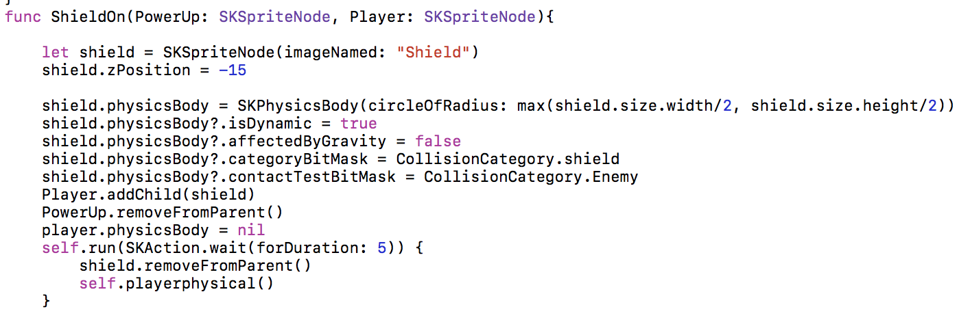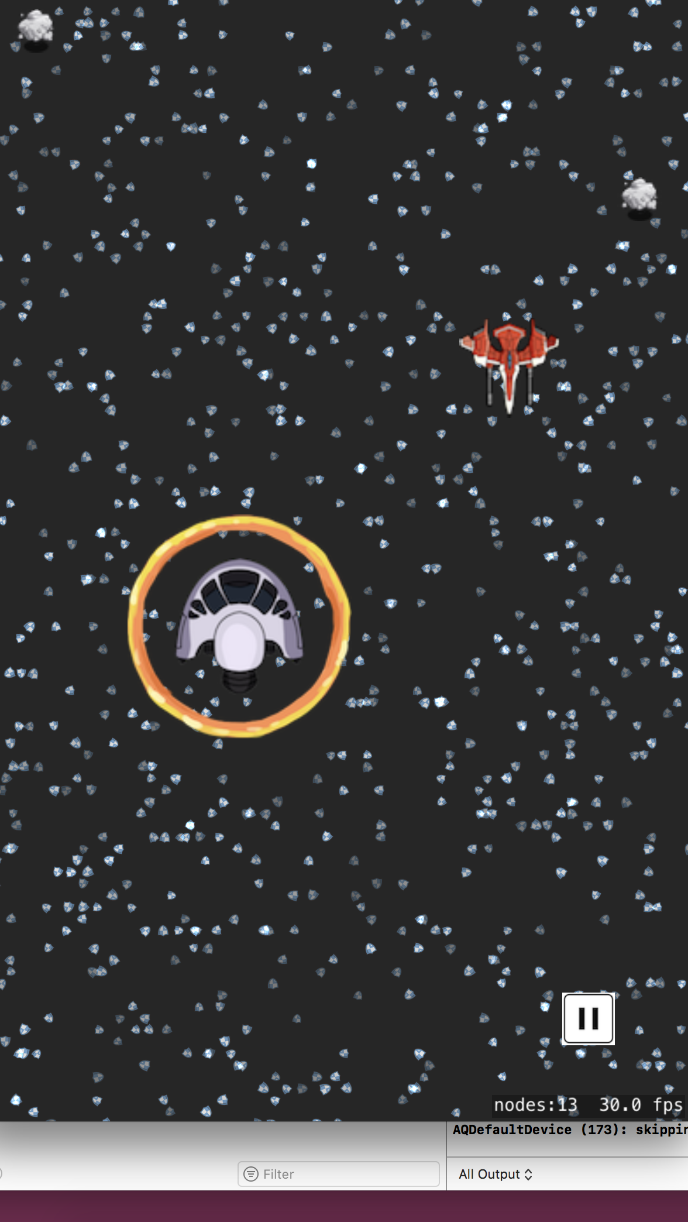

* The Second feature is the Life feature which is explained as Health Feature. And in this feature when the spaceship collided with the enemy spaceships it will decrease a life. And by default there are 3 lives and when all the three of them are finished the game is over and it was important because the user want some time to play as he want some lives to play for some time. The following code is the life code and it is explained in GameScene.swift and the following picture shows the lives and when they are finished mode:

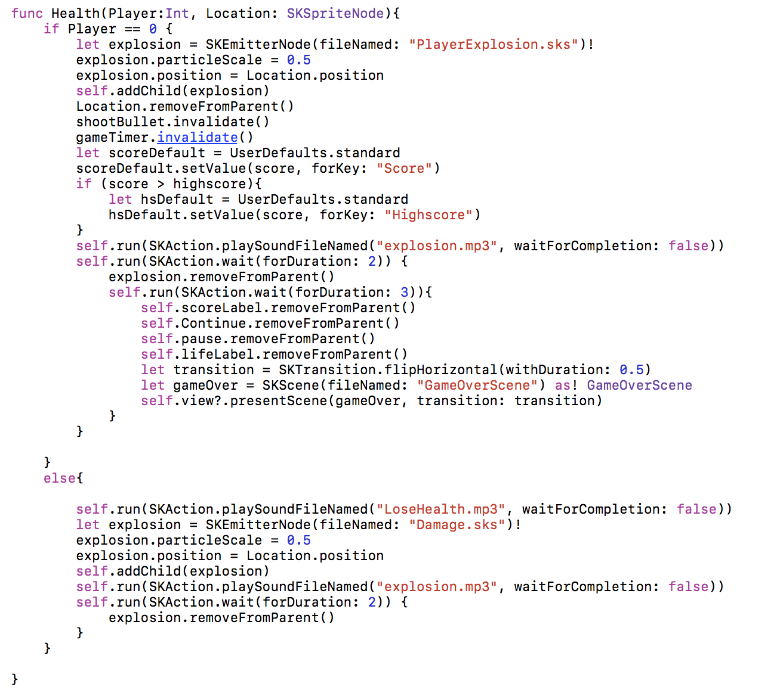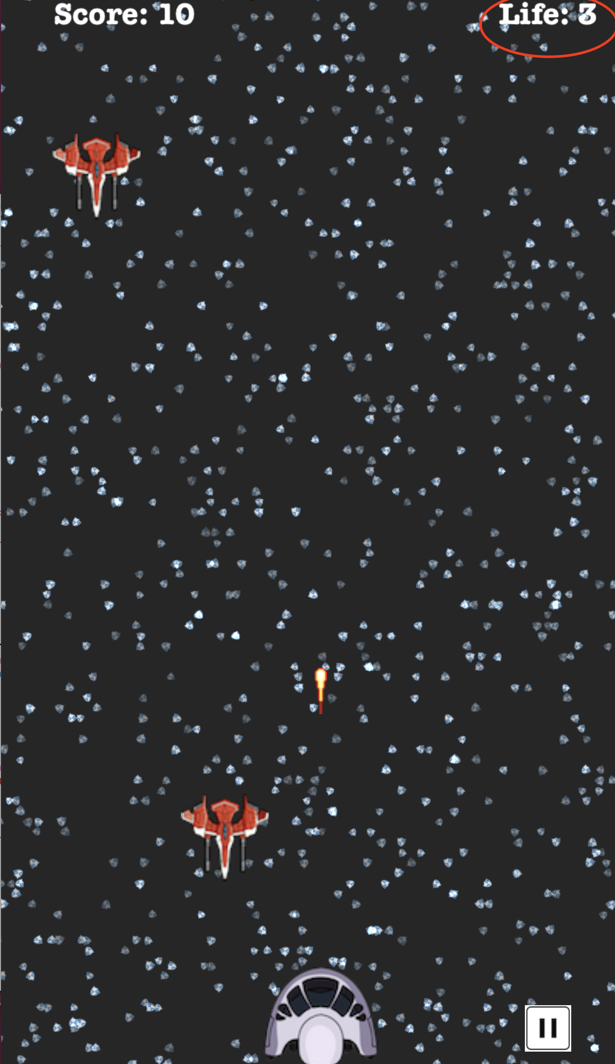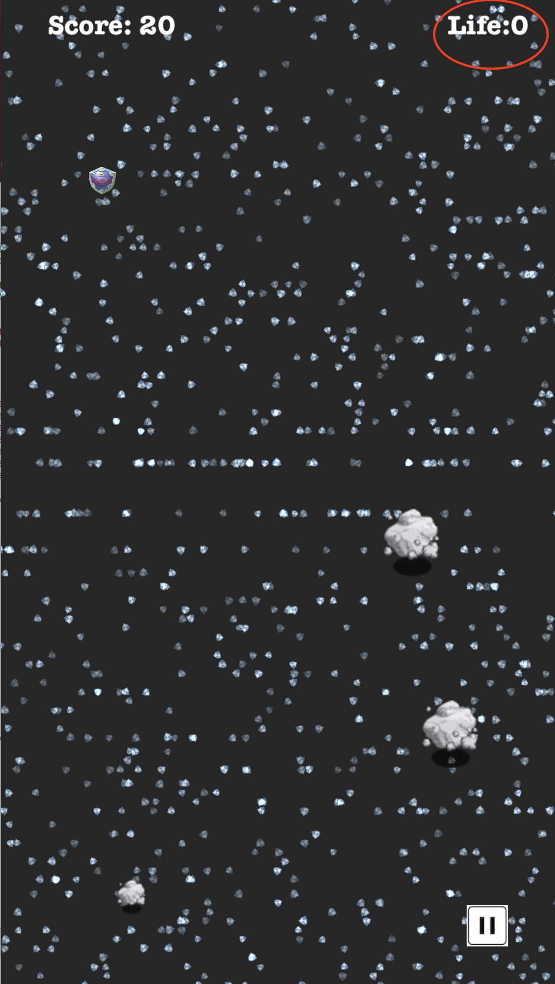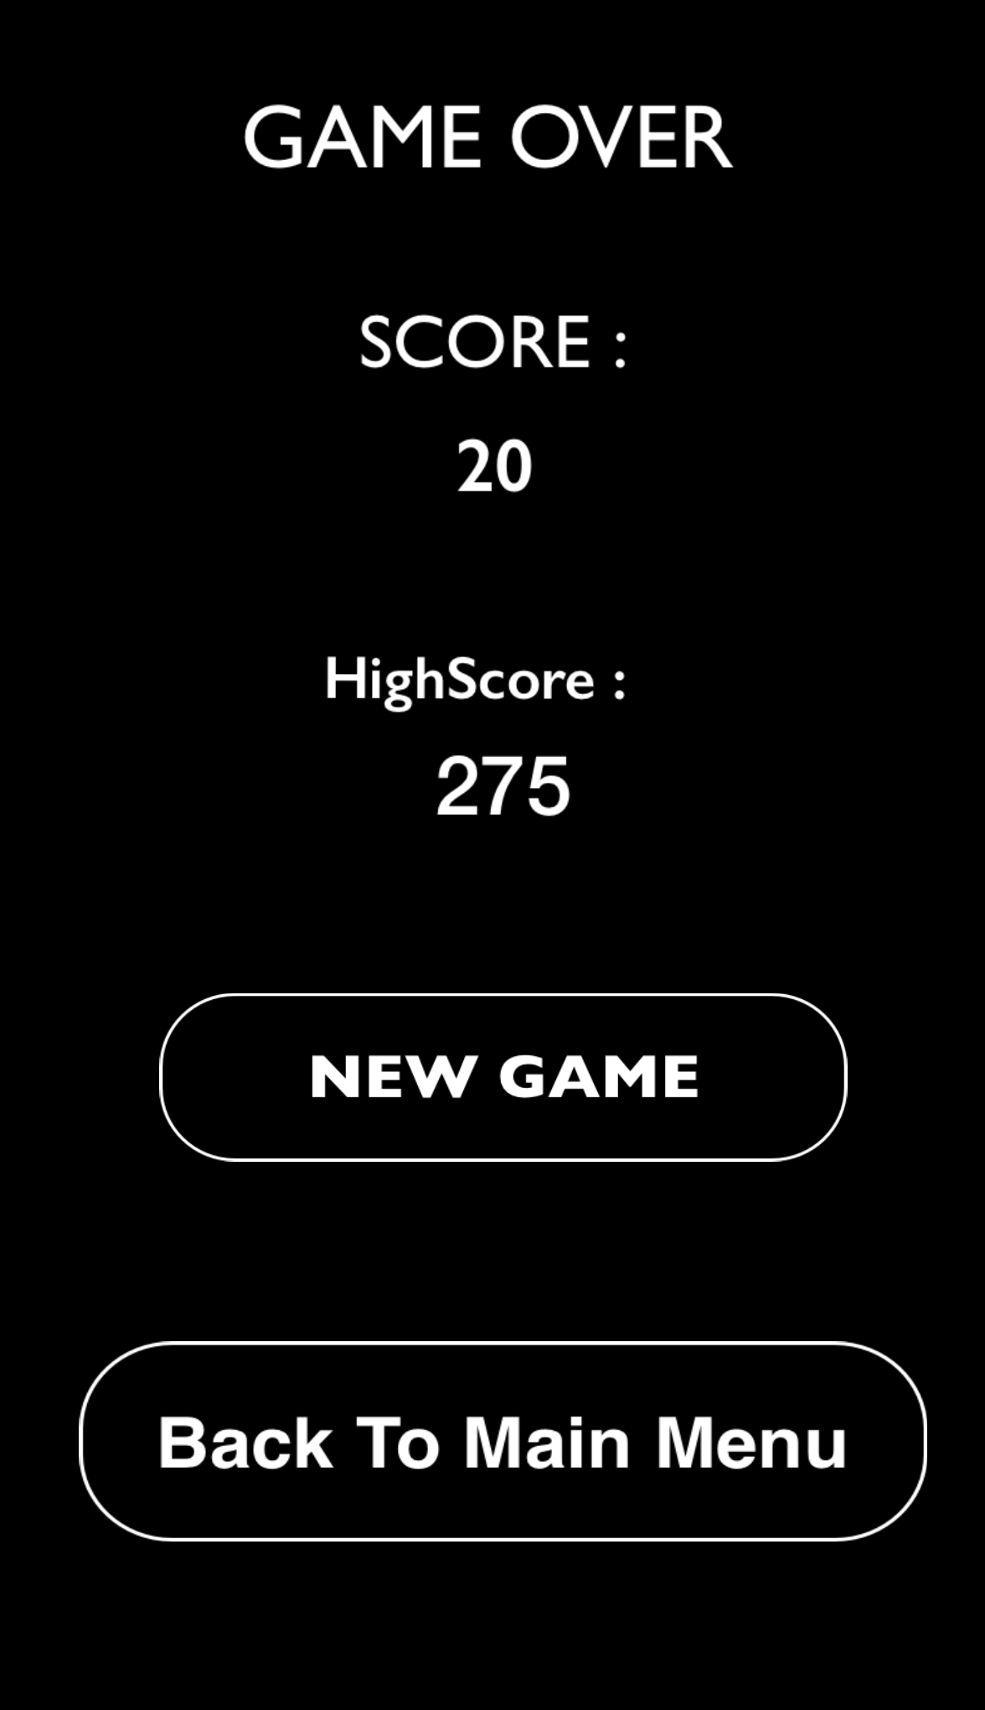

* The Third Key Feature which we have added is the Touch function like we haven’t added the swap/sensor function as most of the screens are not touch screens so that’s why we have added the clickable function as the user clicks on the space ship to move it rather than moving it with a sensor and it was compulsory to do it and the following code shows that feature and we implement that feature code in GameScene.swift: